Vincent van Gogh

**Summary of Van Gogh’s life**

Vincent van Gogh (30 March 1853 – 29 July 1890) was a Dutch Post-Impressionist painter who is among the most famous and influential figures in the history of Western art. In just over a decade he created about 2,100 artworks, including around 860 oil paintings. They include landscapes, still lifes, portraits and self-portraits, and are characterized by bold colors and dramatic, impulsive and expressive brushwork that contributed to the foundations of modern art. His suicide at 37 followed years of mental illness and poverty.

Van Gogh was unsuccessful during his lifetime, and was considered a madman and a failure. He became famous after his suicide, and exists in the public imagination as the quintessential misunderstood genius, the artist "where discourses on madness and creativity converge". His reputation began to grow in the early 20th century as elements of his painting style came to be incorporated by the Fauves and the German Expressionists. He attained widespread critical, commercial and popular success over the ensuing decades, and is remembered as an important but tragic painter, whose troubled personality typifies the romantic ideal of the tortured artist.

**Some highlights of van Gogh’s work**

|  |  |  |
| --- | --- | --- |
| **Artwork title** | **Year Created** | **Location** |
| The potato Eaters | 1885 | Van Gogh Museum, Amsterdam |
| Fishing Boats on the Beach at Saintes-Maries | June 1888 | Van Gogh Museum, Amsterdam |
| Bedroom in Arles | October 1888 | Van Gogh Museum, Amsterdam |
| Sunflowers | 1889 | Van Gogh Museum, Amsterdam |
| The Starry Night | 1889 | Museum of Modern Art, New York City |

**Van Gogh’s life in more detail**

**Early years**

Vincent van Gogh was born on 30 March 1853 in Groot-Zundert, in the southern Netherlands. Van Gogh was a serious and thoughtful child. He was taught at home by his mother and a governess, and in 1860 was sent to the village school. In 1864 he was placed in a boarding school where he felt abandoned, and campaigned to come home. Instead, in 1866 his parents sent him to middle school where he was deeply unhappy. His interest in art began at a young age; encouraged to draw as a child by his mother, his early drawings are expressive, but do not approach the intensity of his later work.

**Emerging artist**

**Nuenen and Antwerp (1883–86)**

In September 1883 Van Gogh moved to Drenthe in the northern Netherlands. In December, driven by loneliness, he went to live with his parents in Nuenen. Van Gogh focused on painting and drawing. Working outside and very quickly, he completed sketches and paintings of weavers and their cottages. During his two-year stay in Nuenen, he completed numerous drawings and watercolors, and nearly 200 oil paintings. His palette consisted mainly of somber earth tones, particularly dark brown, and showed no sign of the vivid colors that distinguish his later work. There was interest from a dealer in Paris early in 1885. Theo asked Vincent if he had paintings ready to exhibit. In May, Van Gogh responded with his first major work, The Potato Eaters, and a series of "peasant character studies" which were the culmination of several years of work. When he complained that Theo was not making enough effort to sell his paintings in Paris, his brother responded that they were too dark, and not in keeping with the bright style of Impressionism.

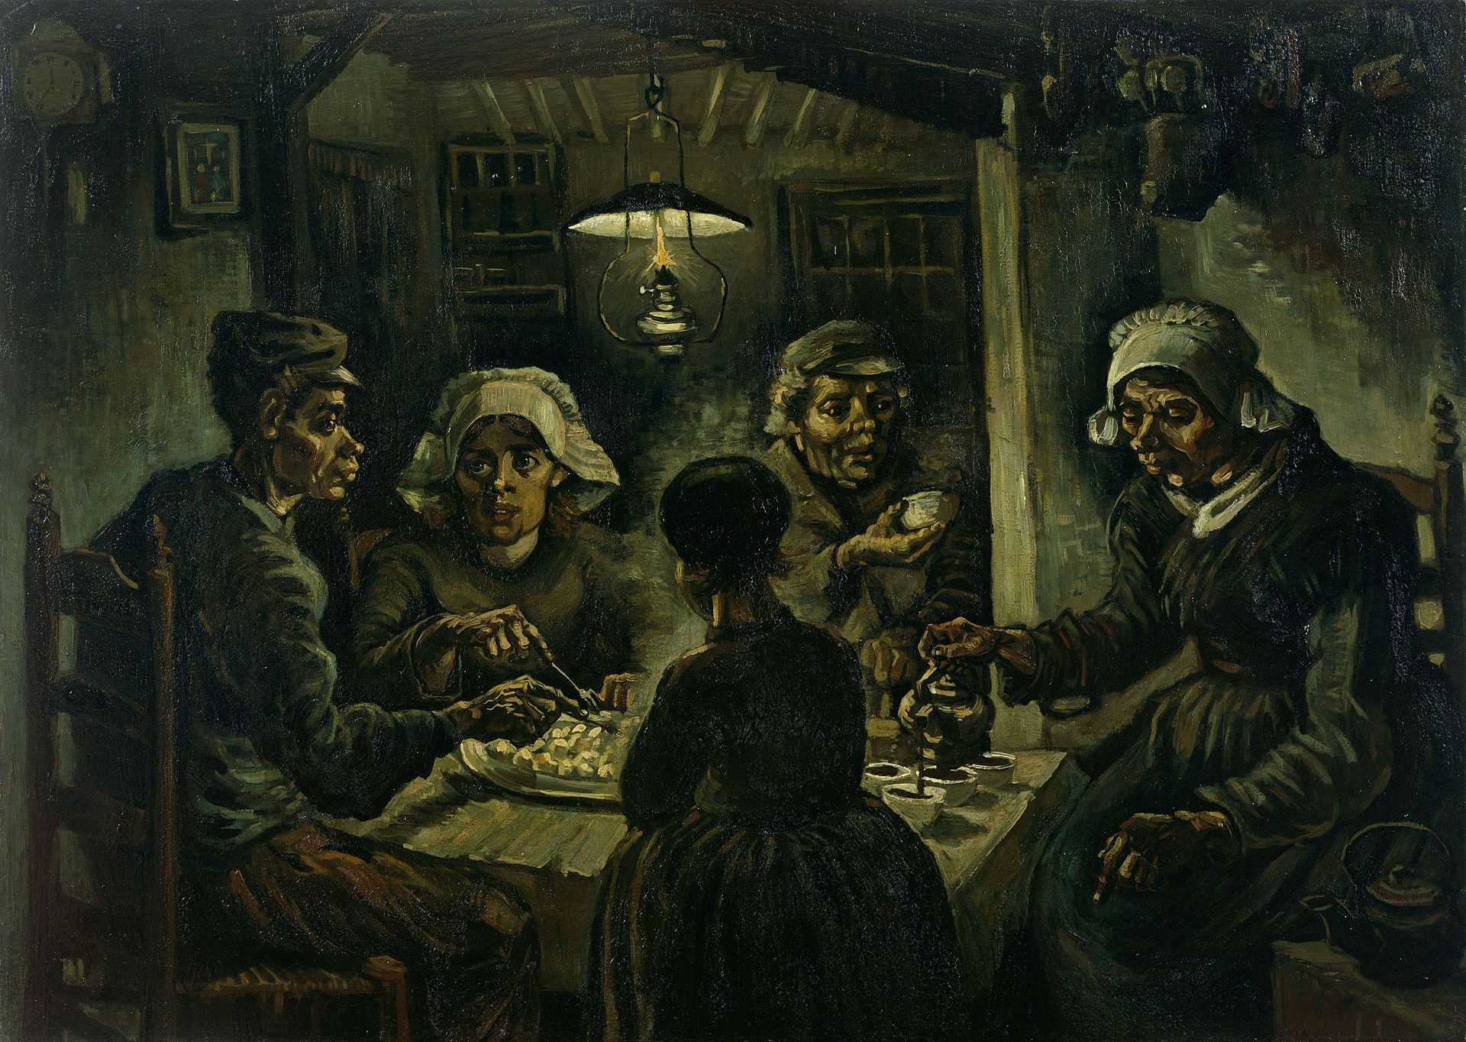

**Paris (1886-88)**

Van Gogh moved to Paris in March 1886 where he shared an apartment with. He painted portraits of friends and acquaintances, still life paintings, views of Le Moulin de la Galette, scenes in Monmartre, Asnières and along de Seine. After seeing the portrait of Adolphe at the Galerie Delareybarette, Van Gogh adopted a brighter palette and a bolder attack, particularly in paintings such as his Seascape at Saintes-Maries (1888).

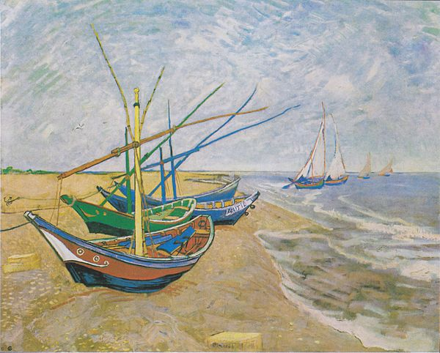

**Artistic breakthrough**

**Time in Arles (1888-89)**

Ill from drink and suffering from smoker's cough, in February 1888 van Gogh sought refuge in Arles. The time in Arles became one of Van Gogh's more prolific periods: he completed 200 paintings, and more than 100 drawings and watercolors. He was enchanted by the local landscape and light; his works from this period are rich in yellow, ultramarine and mauve. His paintings include harvests, wheat fields and general rural landmarks from the area. He later moved to ‘The Yellow House’.

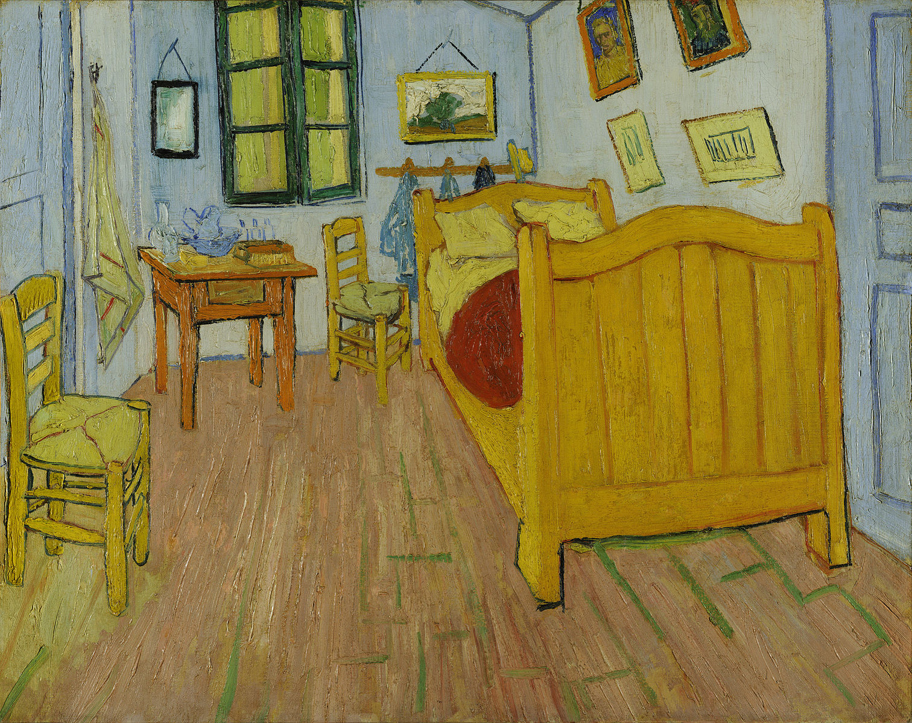

**Gauguin’s visit (1888)**

When Gauguin agreed to visit Arles in 1888, Van Gogh hoped for friendship, and the realization of his idea of an artists' collective. While waiting, in August he painted Sunflowers as a gift to Gauguin. Their relationship began to deteriorate; Van Gogh admired Gauguin and wanted to be treated as his equal, but Gauguin was arrogant and domineering, which frustrated Van Gogh. They often quarreled; Van Gogh increasingly feared that Gauguin was going to desert him, and the situation, which Van Gogh described as one of "excessive tension", rapidly headed towards crisis point.

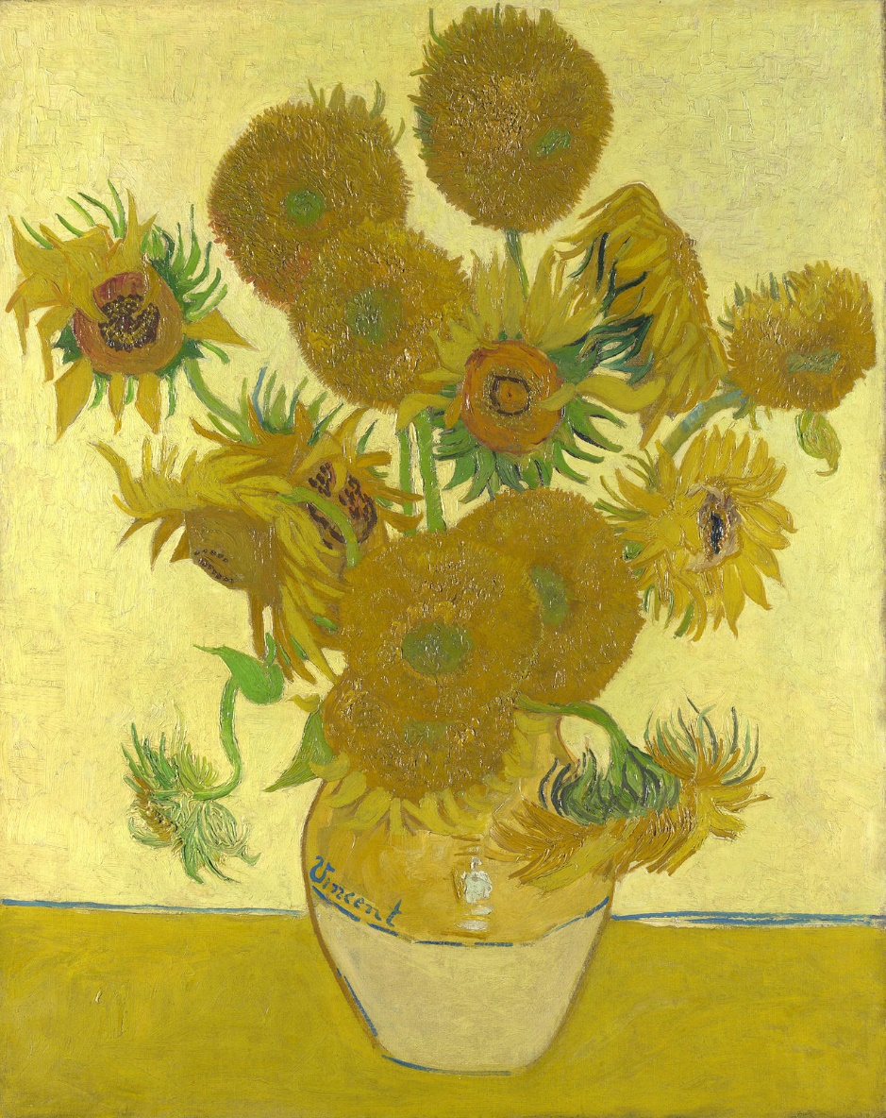

**Hospital in Arles (December 1888)**

The exact sequence of events which led to Van Gogh's mutilation of his ear is not known. Gauguin claimed, fifteen years later, that the night followed several instances of physically threatening behavior.

**Asylum in Saint-Rémy (May 1889-May 1890)**

Van Gogh entered the Saint-Paul-de-Mausole asylum on 8 May 1889. The clinic and its garden became the main subjects of his paintings. He made several studies of the hospital's interiors, such as Vestibule of the Asylum and Saint-Rémy (September 1889). Some of his works from this time are characterized by swirls, such as The Starry Night.

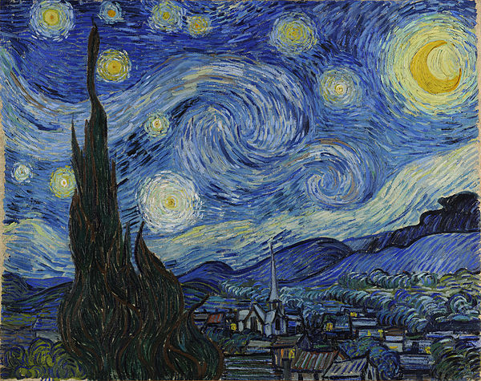

**Van Gogh’s** **death**

On 27 July 1890, aged 37, Van Gogh shot himself. The shooting may have taken place in the wheat field in which he had been painting, or a local barn. The doctors tended to him as best they could. The following morning Theo rushed to his brother's side, finding him in good spirits. But within hours Vincent began to fail. He died in the early hours of 29 July. According to Theo, Vincent's last words were: "The sadness will last forever.